



- The students must first be divided in groups (2-4), create a company and associated logo pertaining to their project at hand.
- Each group will have one Project Manager.
- Each phase (A, B and C) will have a different Project Manager.
- The Project Manager will submit the Group report containing the items in the following sections. However, this is a team effort, and all group members are expected to contribute. If one or more members do not contribute, then they
will receive no marks for the group submission.
- Each Project Manager will submit a Project Manager report at the same time as the group project. A template is provided.
- Each Team Member who is not a project manager for the current phase will
submit a Team Member report at the same time as the group project. A template is provided.
- All report submissions will be digital through FanshaweOnline (FOL)
- Upload a single PDF file containing the entire group submission along with the files in original format
 (5 Marks)
The report should have a cover sheet and follow the provided template.
- All items should be easy to read and understand.
- Any diagram should be large enough to read the text on the diagram. Large diagrams may be broken into parts so long as it is easy to follow.
(5 Marks)
- The report should include (and start with) the Project Charter, Scope Statement and WBS
- Corrections should be made based on feedback from Phase A



 |  (20 Marks)
 | AON Duration Table:  5 marks | A table with your activities, their durations,  predecessors, and successors must be included
 |  | Durations should be reasonable
 | AON Duration Format: | Durations should include units (days)
 | 5 marks | Should match the included WBS
 |  | Should have a code for each task
 | AON Diagram:  5 marks | Complete diagram, although some hammocking is allowed
Include a legend showing what box is for ES, LS,
etc.
A reasonable number of activities should be in
parallel
 | AON Diagram Calculations:  5 marks | Forward pass and backwards pass must be completed and correct
 |  | Identify the critical path

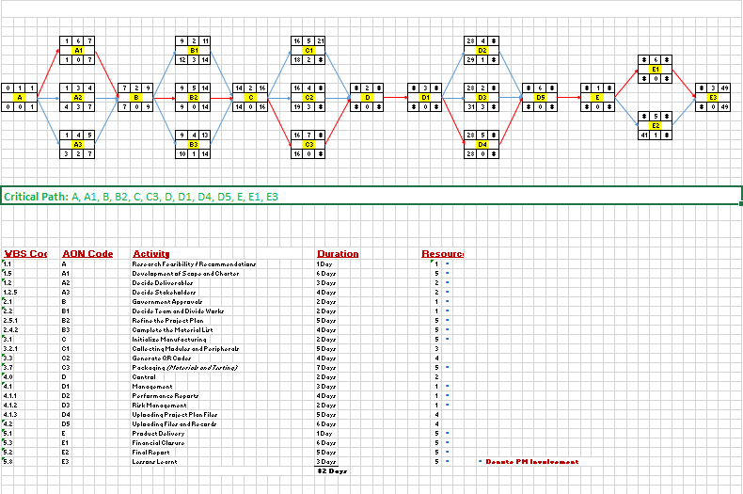


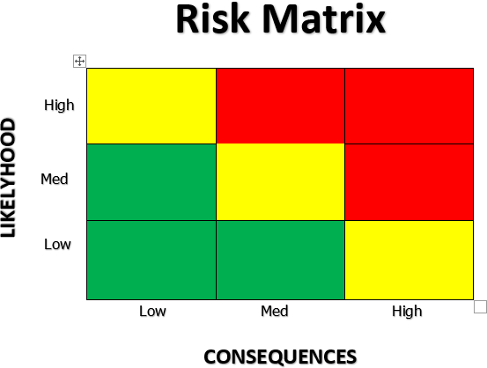
Impact
Probabili

 | (20 Marks)
 | Risk Identification:  5 marks | Identify at least eight risks (or whatever your tutorial  instructor requested)
 |  | Each risk is classified as covered in the class lectures
 | Risk Format: | Each risk is given a low, medium, or high impact
 | 5 marks | Each risk is given a low, medium, or high probability
 |  | Each risk is given a code
Each risk is identified as green, yellow, or red level of
exposure depending on its impact and probability
 | Risk Mitigation:  5 marks | Devise a mitigation strategy for each yellow and red  level exposure risk
Categorize the strategy as one of the types given in the
lecture
 | Risk Matrix: | Create a Risk Matrix
 | 5 marks | Label it properly
Include the code for each identified risk in the correct
cell
 |  | You do not require a risk in every cell
Colour the matrix to match the implied organization
exposure level of each risk (green, yellow, red)

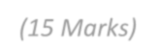

 | (15 Marks)
 | Gantt Chart:  5 marks | Create a simple Gantt chart in Excel.
 |  | Activities should match your WBS and AON
 |  | Leave activities at “0% Complete for Phase B”
 | Gantt Format: | The unit of time should be days
 | 5 marks | The dates can be real dates or start with “Week 1”
 |  | Include arrows to show relations between task
Corner-to-corner tasks can imply Finish-to-Start
relations without an arrow
 |  | All relations can be Finish-to-Start
 |  | The relations between tasks should match your AON
 | Milestones:  5 marks | Identify the end of activities that match your Milestones on your Gantt Chart with a diamond 𝘘. (You can also add the planned Milestone dates as a different symbol like ◆.)
Include a paragraph comparing your expected
milestones in your Charter to your milestone dates in
your Gantt. They do not need to be the same!

